***IT 341***

***Skills Exam 1***

**NAME:**

**G Number:**

**Assignment Objectives:**

* Design a logical topology
* Configure the physical topology
* Configure the logical topology
* Verify the network connectivity

**Instruction:**

* You need to upload your pka file along with this document separately on BB.

**Task 1: Design the logical LAN topology (30 points)**

Given the network 192.168.100.0/24, we are going to segment this network into two subnets, Subnet A and Subnet B. The hosts requirement for Subnet A is 90 and for Subnet B is 20. Please calculate the new subnet masks for each subnet and fill in the tables below:

|  |  |
| --- | --- |
| **Subnet A** | **Your Answer** |
| Subnet Mask in Decimal (3 points) |  |
| Subnet Mask in Binary (2 points) |  |
| Number of Useable Hosts in this Subnet (2 points) |  |
| IP Network Address (2 points) |  |
| First valid IP Address (2 points) |  |
| Last valid IP Address (2 points) |  |
| Subnet Broadcast IP Address (2 points) |  |

|  |  |
| --- | --- |
| **Subnet B** | **Your Answer** |
| Subnet Mask in Decimal (3 points) |  |
| Subnet Mask in Binary (2 points) |  |
| Number of Useable Hosts in this Subnet (2 points) |  |
| IP Network Address (2 points) |  |
| First valid IP Address (2 points) |  |
| Last valid IP Address (2 points) |  |
| Subnet Broadcast IP Address (2 points) |  |

**Task 2: Build the Network in PT (20 points)**

Please build the network based on the following topology in Packet Tracer using the right cables and interfaces.

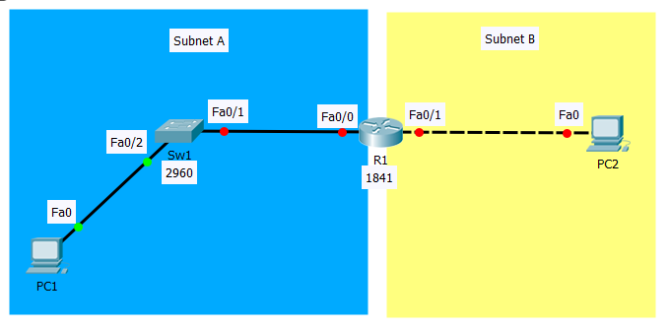

**Task 3: Secure the Router (10 points)**

Secure Router1 using the information below:

|  |  |
| --- | --- |
| **Task 3** | **Specification** |
| Router name | Router1 |
| Encrypted privileged exec password | cisco |
| Console password | class |
| Telnet password | class |

**Task 4: Router and hosts configuration (30 points)**

Configure Router1 and the two PCs using the given information in the table below and save your configuration at the end.

|  |  |  |  |  |
| --- | --- | --- | --- | --- |
| Devices | Interfaces | IP Address | Subnet Mask | Default Gateway |
| Router1 | F0/0 | The first valid IP address in Subnet A | Subnet A Subnet Mask | N/A |
|  | F0/1 | The first valid IP address in Subnet B | Subnet B Subnet Mask | N/A |
| PC1 | NIC | The last valid IP address in Subnet A | Subnet A Subnet Mask | Router’s F0/0 interface address |
| PC2 | NIC | The last valid IP address in Subnet B | Subnet B Subnet Mask | Router’s F0/1 interface address |

**Task5: Verify Connectivity (10 points)**

After configuring the router and the PCs, you need to verify the connectivity between PC1 and PC2 using ping command.